DIGITAL MARKETING

Assignment 1- Create a blog. Customizing the theme design and

Posting a new article with 500 words

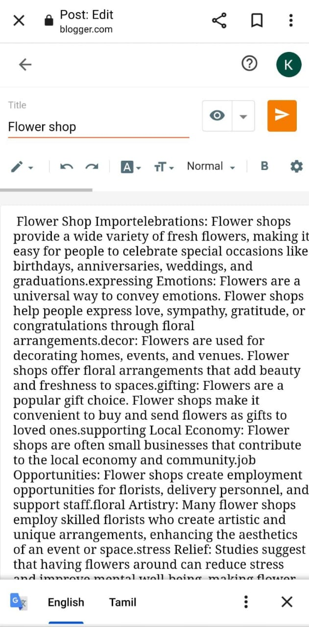

Blogger post link:

<https://www.blogger.com/blog/post/edit/1327674596836046575/3147363813037045909>

Passage:

FLOWER SHOP

“Love is the flower you’ve got to let grow”

Flower Shop Importelebrations: Flower shops provide a wide variety of fresh flowers, making it easy for people to celebrate special occasions like birthdays, anniversaries, weddings, and graduations.

Expressing Emotions: Flowers are a universal way to convey emotions. Flower shops help people express love, sympathy, gratitude, or congratulations through floral arrangements.

Decor: Flowers are used for decorating homes, events, and venues. Flower shops offer floral arrangements that add beauty and freshness to spaces.

Gifting: Flowers are a popular gift choice. Flower shops make it convenient to buy and send flowers as gifts to loved ones.

Supporting Local Economy: Flower shops are often small businesses that contribute to the local economy and community.

Job Opportunities: Flower shops create employment opportunities for florists, delivery personnel, and support staff.

Floral Artistry: Many flower shops employ skilled florists who create artistic and unique arrangements, enhancing the aesthetics of an event or space.

Stress Relief: Studies suggest that having flowers around can reduce stress and improve mental well-being, making flower shops important for people's emotional health.

Environmental Impact: Flower shops play a role in promoting sustainable and eco-friendly practices in the floral industry.in summary, flower shops are important for their role in enriching human experiences, supporting local economies, and promoting well-being through the beauty of flowers.

A flower shop, also known as a florist or flower store, is a retail establishment that specializes in the sale of fresh, dried, and artificial flowers, as well as various floral arrangements and related accessories. These shops offer a wide variety of flowers and plants, often catering to special occasions and events. The primary functions of a flower shop include: selling Fresh Flowers: Flower shops.